**Project Report: Hotel booking website (LuxeStay)**

**Conceptual Phase**

**Introduction**

The hotel booking web service effectively utilizes modern web technology to provide users with an easy way to view, select and reserve hotel accommodation. Online booking platforms have revolutionized the hospitality industry, providing users with convenience, variety, transparency and security. In this project we have tried to solve one of the problems which users face while booking for a hotel. We have provided all the features which the hotel booking website should have. We also focused on the user’s convenience to improve the user experience. Our main motive behind this project is to revolutionize the online booking of the hotels. We have enabled the user to look for a room on the various categories such as single room, double room etc. Various price range, various services which are optional. If the user wants to have that he can add it while booking otherwise he can skip that. This is done because just to make sure that all the user can make the booking from person with low income to rich class everyone.

**Purpose**

The project seeks to improve user experience by providing convenience, diversity, transparency and security. Additionally, it targets operational efficiency, insight generation, customer engagement and revenue maximization for hotel managers. Not only the managers, but also the customers who want to book the hotel rooms online. And also we want to revolutionize the hotel booking.

**Scope**

The scope of the program is comprehensive and inclusive including user registration, furniture inventory, inventory system, payment processing, staff management and customer support

**DATABASE SCHEMA:**

The database schema is designed in such a way that each and every entity and the attributes are covered and also to store and retrieve all kind of information which is expected in the hotel booking system.

The database structure contains tables which include

* Payment: This is the table which will have all the payment records.
  + Attributes:
    - id
    - Name
    - Email
    - RoomType
    - Bed
    - NoofRoom
    - cin
    - cout
    - noofdays
    - roomtotal
    - bedtotal
    - meal
    - mealtotal
    - finaltotal
* Roombook: This is the table which will have all the room booking records.
  + Attributes:
    - id
    - Name
    - Email
    - Country
    - Phone
    - RoomType
    - Bed
    - Meal
    - NoofRoom
    - cin
    - cout
    - nodays
    - stat
* Signup: This is the table to store the user’s credentials when they register to the website.
  + Attributes:
    - UserID
    - Username
    - Email
    - Password
* Room: This is the table which stores all the room information.
  + Attributes:
    - id
    - type
    - bedding
    - room_img
    - wifi
    - food
    - spa
    - gym
    - pool
* Emp_login: This table stores the employee login credentials.
  + Attributes:
    - empid
    - Emp_Email
    - Emp_Password
* Staff : This is the table which stores the staff information which is added by the admin.
  + Attributes:
    - id
    - name
    - work
* Contact_us: This is the table which stores the query which is made by the user.
  + Attributes:
    - name
    - email
    - subject

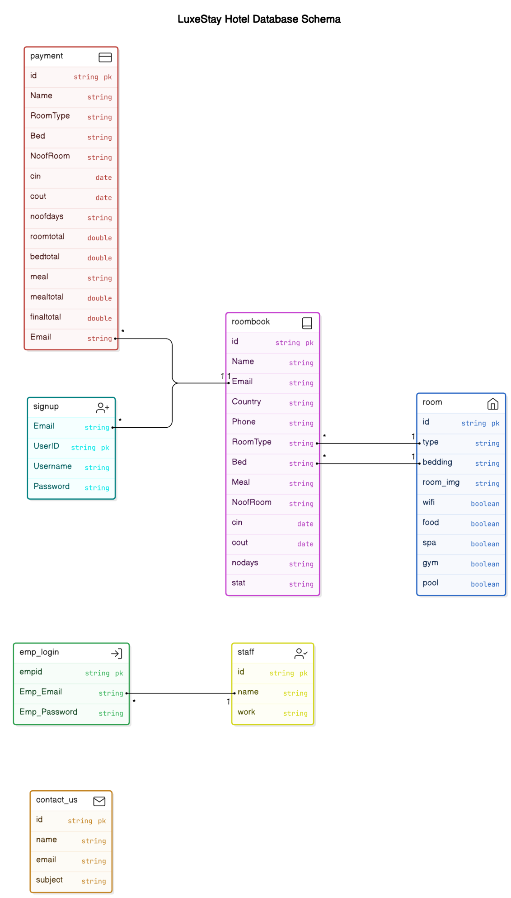

**Features**

Key features include an intuitive interface, spacious furniture, user-friendly spreadsheets, real-time verification analytics, secure payment processing and administrative dashboards

1. User interaction: User interacts with the website by browsing the rooms, choosing the rooms, and also booking the rooms.
2. Frontend processing: Frontend components such as HTML, CSS and Javascript which is used to process information along with the PHP which is used to communicate with database.
3. Backend processing: PHP is used to serve the response to frontend which is received from the database.
4. Database interaction: PHP scripts interact with the MySQL database to retrieve the data from the database or to store the data into the database. And also the operations like CRUD is done with the help of PHP.

**COMPONENT INTERACTION:**

Frontend components (HTML, CSS, JavaScript) facilitate user interaction, while backend counterparts (PHP, MySQL) manage server-side operations and data. Seamless communication ensures interoperability between the front end and the back end.

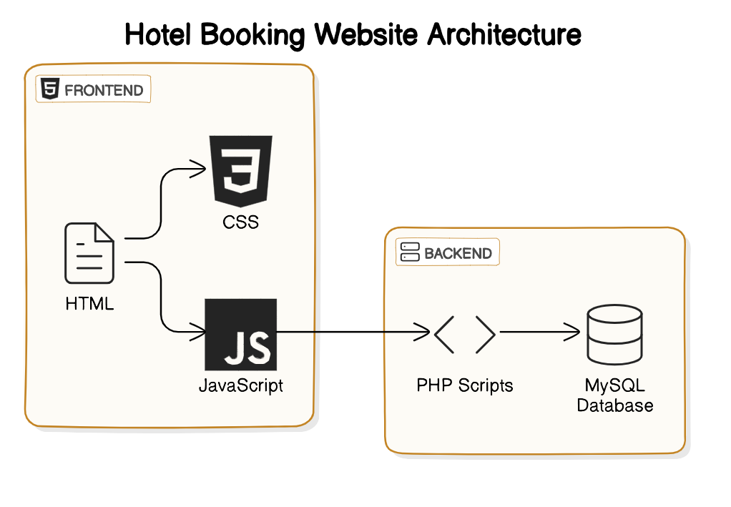

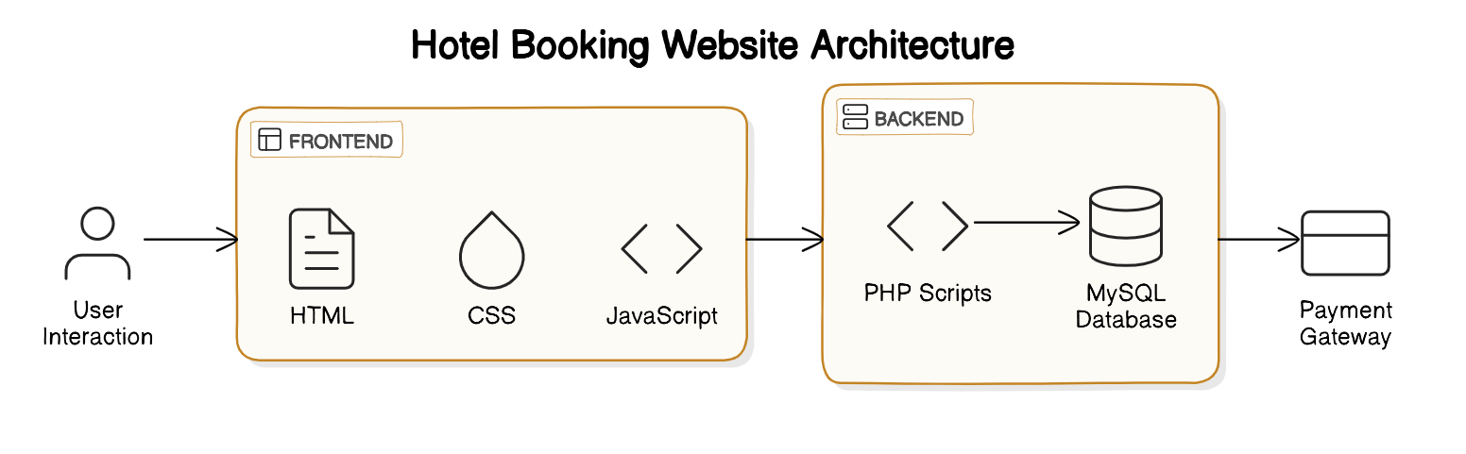

**Conclusion**

The system which we have developed is to solve one of the major problems which is faced by many people. With the help of our system we try to solve that problem. And day by day all the sectors are being revolutionized including the hotel or lodging sector we are trying to contribute on to that revolution. We came up with a web solution that help both the hotel staff and also the normal users making it easy for them to book the hotel and view all the options they have where as it is helpful for hotel staff as it is more convenient to handle.